AI Usage DISCLOSURE FORM

1. Team Details
Team Name: Hacktivators
Project / Product Name: ATLAS(Autonomous Trading Logic & Advisory System
) - AI Trading Advisor
Organization / Institution (if any): R. V. College of Engineering
Submission Date: 8 May 2026

2. AI Usage Declaration
Did your team use any Artificial Intelligence (AI) in developing this project? Yes

3. Purpose of AI Usage ( Brief Details)
Idea generation / brainstorming : Conceptualizing the "Multi-Agent Consensus" model and the HERMES Hindsight architecture..
Code generation or assistance : Extensive use of Antigravity (Gemini 3 Flash) for backend logic, FastAPI infrastructure, and asynchronous loop management.
UI / UX design :AI-assisted styling for the dark-mode Glassmorphism dashboard and layout optimization.
Content creation :Automated generation of daily "HERMES Post-Mortem" market reports using GPT-4o.
Data analysis : Using PPO (Reinforcement Learning) models and Mistral-7B for live sentiment extraction and indicator interpretation.
Testing / debugging : AI-driven simulation scripts used to audit 365-day historical performance and verify signal accuracy.
Other : Background process management (CoPAW).

4. Feature Origin Classification ( Please add/delete based on the number of the feature)

Feature 1: 5-Agent Consensus Engine
- Feature Name: Multi-Agent Decision Engine
- Origin: Both
- Description:
AI Tools / Platforms Used: OpenAI GPT-4o-mini, Mistral-7B
Prompt Used:
"Analyze these 5 technical indicators and news sentiment. Provide a trade recommendation with a confidence score and detailed reasoning."
Output Summary:
Generated structured JSON-based trade decisions (EXECUTE / WAIT) along with weighted confidence scores, reasoning, and market interpretation from multiple AI agents.
Modification / Customization:
Developed a custom “Strategy DNA” voting framework around the AI-generated outputs to maintain decision stability across different market regimes such as Bull, Bear, and Chop conditions.

Feature 2: HERMES Hindsight Agent
- Feature Name: Autonomous Post-Mortem Report Generator
- Origin: AI-Generated
- Description:
AI Tools / Platforms Used: OpenAI GPT-4o
Prompt Used:
"Review these 20 trades. Identify the top 3 failure patterns and suggest how to adjust the strategy weights for tomorrow."
Output Summary:
Generated automated markdown-based performance reports, identified recurring trading failures, and recommended dynamic weight adjustments for subsequent trading sessions.
Modification / Customization:
Integrated the AI-generated analysis into the custom CoPAW automation wrapper for continuous 24/7 autonomous scheduling and reporting.

Feature 3: RL Strategist (PPO Model)
- Feature Name: Reinforcement Learning Pattern Recognition
- Origin: AI-Generated
- Description:
AI Tools / Platforms Used: Stable-Baselines3 (PPO Algorithm)
Prompt Used:
N/A — Model trained algorithmically on 1-year historical OHLCV (Open, High, Low, Close, Volume) market data.
Output Summary:
Generated a serialized reinforcement learning policy model capable of identifying non-linear price movement patterns and momentum opportunities in ETH/USD markets.
Modification / Customization:
Implemented a custom reward function prioritizing drawdown reduction and risk minimization instead of maximizing raw profit alone, improving overall system safety and stability.

Feature 4: Live XAI Dashboard
- Feature Name: Explainable AI (XAI) Trading Interface
- Origin: Both
- Description:
AI Tools / Platforms Used: Mistral-7B (via Hugging Face API), Gemini Flash
Prompt Used:
"Explain this indicator (RSI: 33) to a beginner in one short sentence."
Output Summary:
Generated simplified plain-English explanations and contextual tooltips for technical indicators displayed on the live trading dashboard.
Modification / Customization:
Designed and implemented a custom Glassmorphism-based UI using vanilla JavaScript and CSS to visualize AI-generated explanations and insights in real time.

5. Ethical & Compliance Confirmation
AI usage complies with guidelines and policies. Yes
No proprietary or copyrighted data misused. I Agree

6. Declaration & Sign-Off
Name of Team Representative: Lalan P
Role: Leader
Signature: 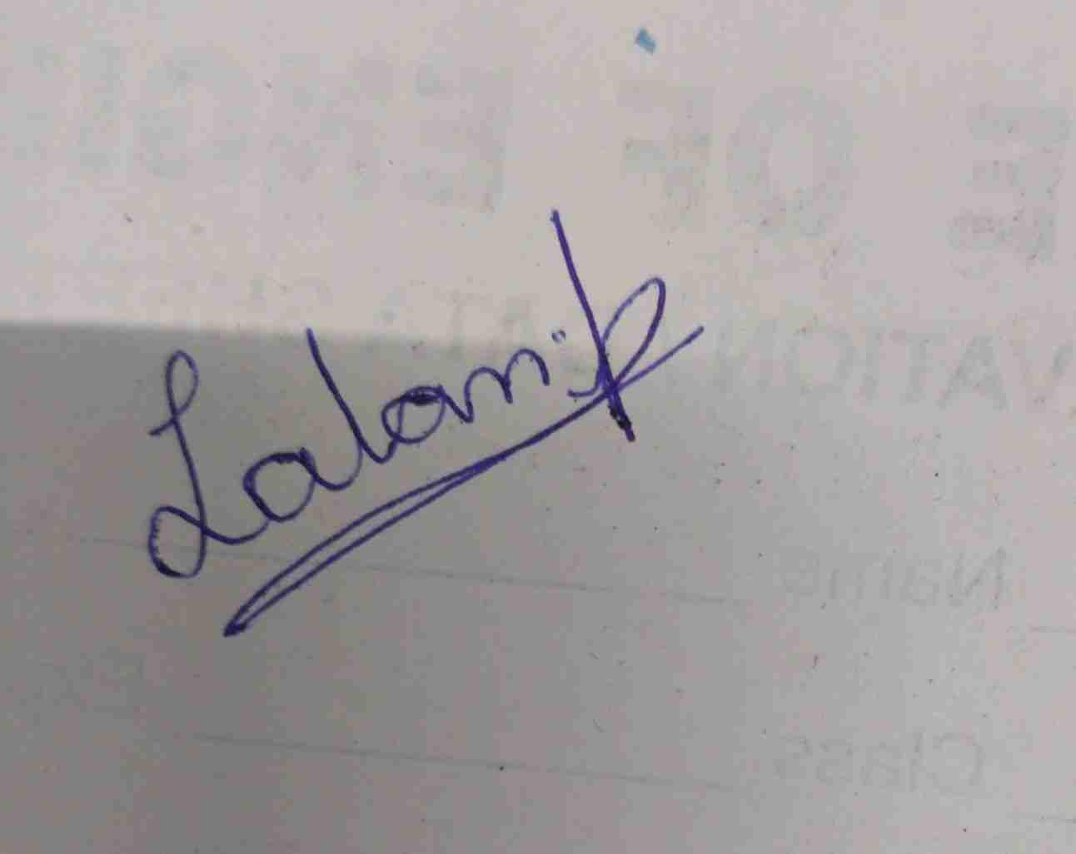
Date: 8 May, 2026

